IoT Smart Walker for Elderly Assistance System

Project:
Media Mangement

Student Name:
Haris

Group Members:
Hassan
Haris
Nouman
Zain

Date:
January 2025

Introduction
The global elderly population is increasing rapidly, creating urgent demands for healthcare solutions that maintain independence while monitoring health. By 2050, over 2 billion people will be aged 60 or older, requiring the need for practical home-based monitoring technologies.
Walkers are essential for many elderly individuals, but users are particularly vulnerable to undetected cardiovascular and respiratory issues, including irregular heart rhythms, low blood oxygen levels, and sudden physiological deterioration. These conditions often develop silently until they lead to falls, fainting, or acute medical emergencies.
Most existing monitoring systems depend on hospitals or continuous caregiver supervision, making them costly and impractical for daily home use. Standard walkers provide mobility support but offer no mechanism for continuous health assessment.
The IoT Smart Walker addresses this gap by embedding real-time monitoring of heart rate, oxygen saturation (SpO₂), and body temperature directly into the walker. By tracking these parameters during everyday activity, the system enables early detection of health deviations, timely alerts, and improved safety and independence for elderly users.

Technical Solution and Architecture

System Overview
The IoT Smart Walker uses a three-layer architecture: hardware interface, signal processing, and application/alert integration. A Raspberry Pi 3 serves as the main controller, managing sensor communication, data processing, and system coordination. The modular design allowed us to develop hardware drivers, signal processing algorithms, and application logic independently while keeping system cohesion.
Sensors include:
- MAX30102 pulse oximeter: monitors heart rate and SpO₂ using photoplethysmography with red (660 nm) and infrared (880 nm) light.
- DS18B20 temperature sensor: measures body temperature with ±0.5 °C accuracy.
The MAX30102 communicates via I2C, while the DS18B20 uses the 1-Wire protocol. Both sensors are connected to the Raspberry Pi for continuous data acquisition.

Hardware Interface
The MAX30102 uses a FIFO buffer system to store 32 samples of red and infrared light readings, enabling continuous measurement with minimal processor load. The sensor driver initializes device registers to configure interrupts, sampling rate (100 Hz), LED pulse width (411 µs), ADC range (4096 nA), and operational mode.
The system continuously polls the FIFO buffer. Data is read in 6-byte packets and converted into 18-bit red and infrared measurements. Circular buffer wrap-around logic makes sure no data is lost.
The DS18B20 temperature sensor provides digital readings through a GPIO pin with a pullup resistor, delivering accurate body temperature measurements integrated with the health monitoring system.

Signal Processing
Heart rate and SpO₂ are computed from raw sensor data using the following pipeline:
- Heart Rate Calculation o Data is processed in 100-sample windows (~4 s at 25 Hz).
  - DC offset removal is performed, then the signal is inverted to detect valleys as peaks.
  - A 4-point moving average reduces noise from motion.
  - Peak detection uses an adaptive threshold; peaks too close together (<160 ms) are removed.
  - Heart rate (BPM) = (Sampling Frequency × 60) / average peak interval.
- SpO₂ Calculation o AC and DC components are extracted from red and infrared signals.
  - The ratio-of-ratios method computes R = (Red_AC × IR_DC) / (IR_AC × Red_DC).
  - SpO₂ is derived using the calibration formula:
SpO₂ = -45.060 × (R²)/10000 + 30.054 × R/100 + 94.845 o Accuracy is within ±2% for saturation levels from 70–100%.
Motion artifacts are mitigated through filtering, adaptive thresholds, and sliding window averaging, making sure measurements are reliable even when the walker is in motion.

Application Layer and Alert System
The system uses a threaded application design, allowing sensor data collection to run continuously in the background while the main program manages alerts and logging.
- Monitoring loop: executes every 10 ms, reading available samples and maintaining a rolling 100-sample buffer.
- BPM smoothing: moving average over the last 4 readings stabilizes heart rate output.
- Contact detection: if red and IR readings fall below 50,000 units, BPM is set to zero to avoid false alerts.
- Alert thresholds:
o SpO₂ < 92% → oxygen alert o Heart rate < 50 or > 120 BPM → heart rate alert o Temperature > 37.5 °C → fever alert
Alerts are communicated using LEDs and buzzer signals for immediate local notification.

Results and Analysis
The system consistently measured heart rate within ±5 BPM of reference pulse oximeters and SpO₂ within ±2% for readings above 90%.
- Motion robustness: the moving average and adaptive threshold algorithm effectively filtered out vibration noise from walker use.
- Thread stability: the sensor thread ran continuously for over 2 hours without memory leaks or timing errors.
- Resource utilization: CPU usage remained below 15%, and memory usage stabilized near 120 MB, leaving room for future features like data logging or wireless alerts.
Limitations: rapid heart rate changes or arrhythmic patterns reduce accuracy; temperature sensing requires further validation. Advanced motion compensation (e.g., accelerometer assisted filtering) could further enhance reliability.

Individual Contribution, Learnings, and Challenges My Responsibility
I implemented the signal processing algorithms for heart rate and SpO₂, including:
- DC offset removal, peak detection, and smoothing filters.
- Ratio-of-ratios calculation for SpO₂.
- Integration of algorithms with the main threaded application for real-time monitoring.
I coordinated with hardware and application teams to ensure buffer sizes, sampling rates, and alert thresholds were aligned.

My Learnings
- Gained deep understanding of photoplethysmography and physiological signal interpretation.
- Learned advanced digital signal processing techniques to reduce noise and extract meaningful physiological data.
- Developed practical experience in threaded application design for real-time embedded systems.
- Improved skills in algorithm validation and calibration against clinical reference devices.

My Challenges
- Ensuring reliable peak detection under motion artifacts; iterative threshold tuning was necessary.
- Correctly implementing AC/DC component extraction for SpO₂; initial interpolation errors required step-by-step debugging.
- Balancing algorithm accuracy with computational efficiency on a Raspberry Pi 3.
- Extensive testing and validation with real-world sensor data under different activity levels.

Project Implementation Photos
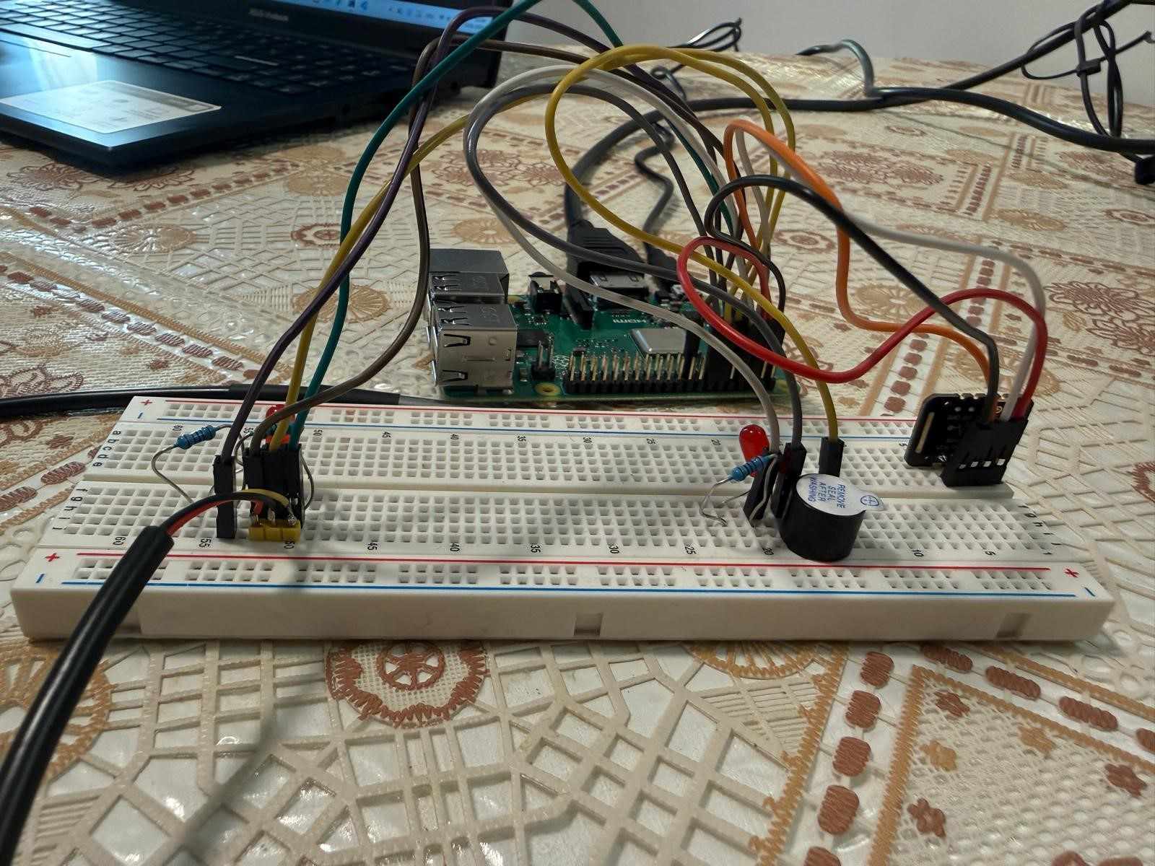
Figure 1: Hardware setup (Raspberry Pi + sensors on breadboard) Figure 2: Wiring overview (side view)
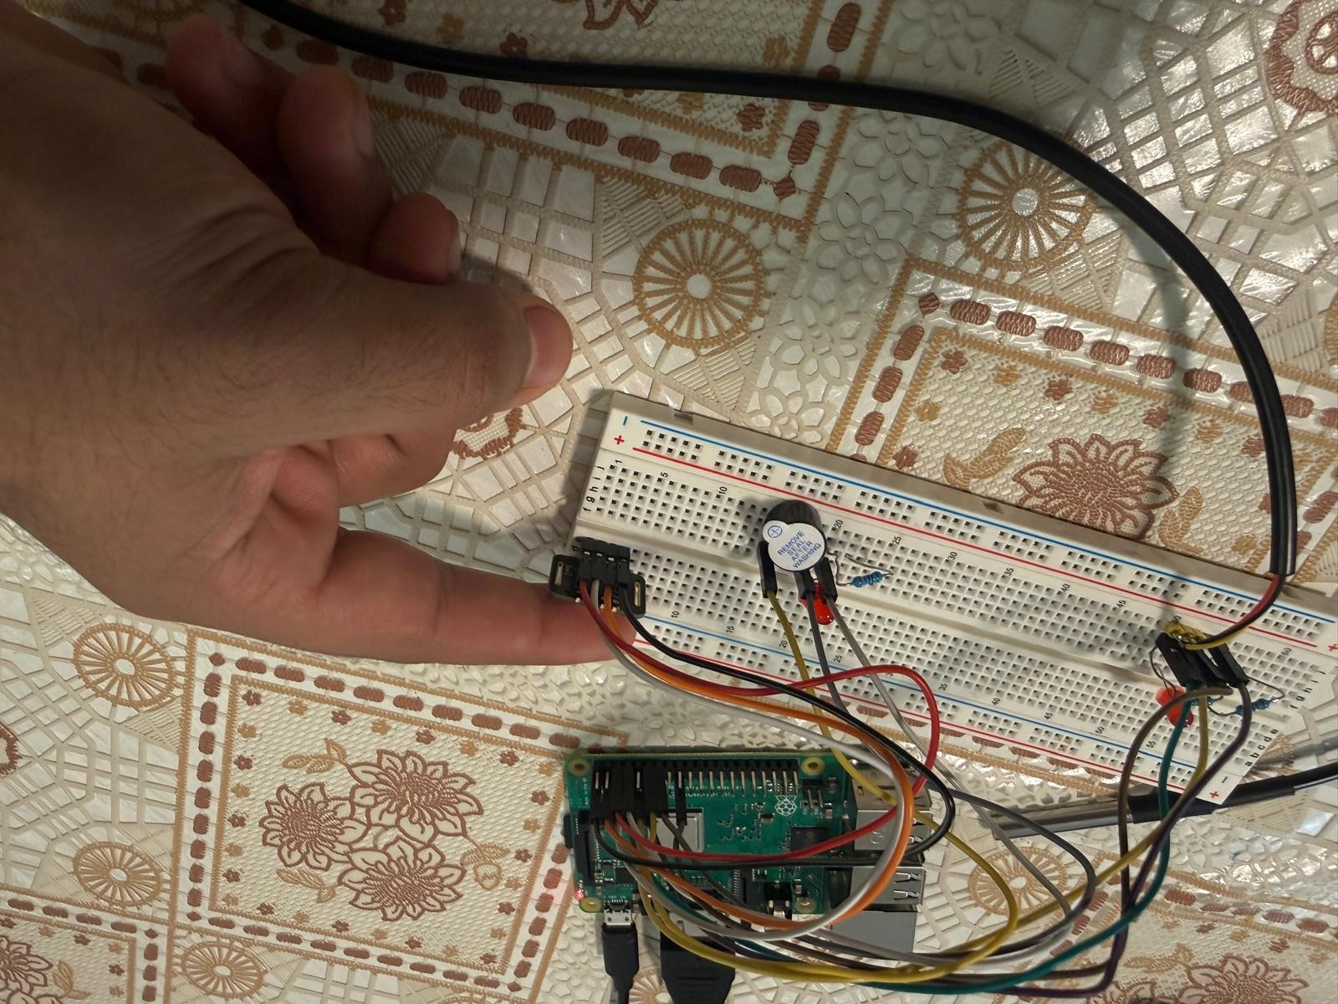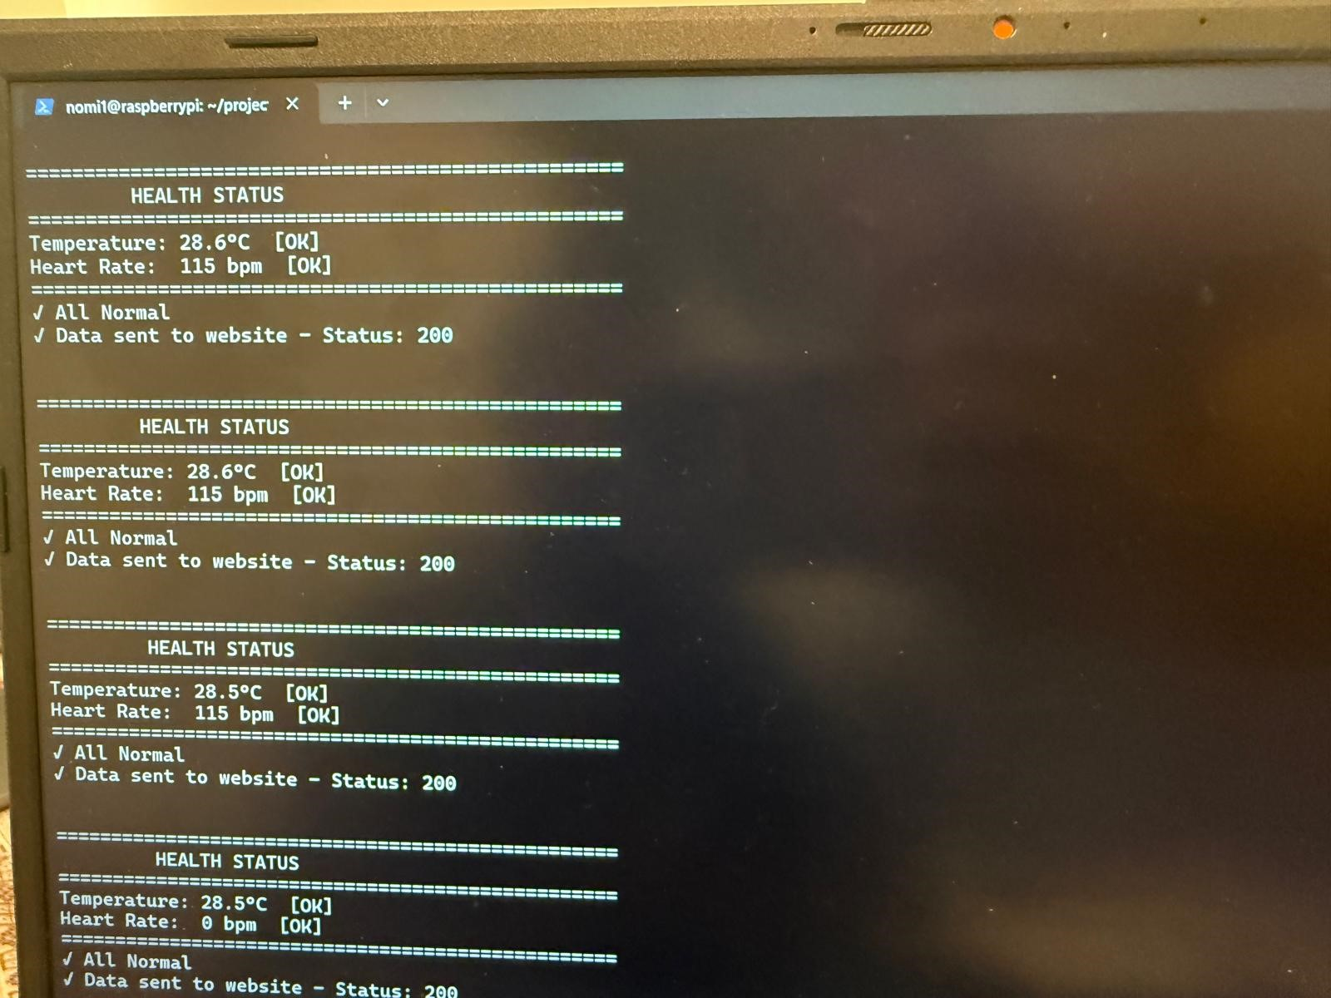
Figure 3: Wiring overview (top view) | Figure 4: Console output (Normal status + HTTP 200)
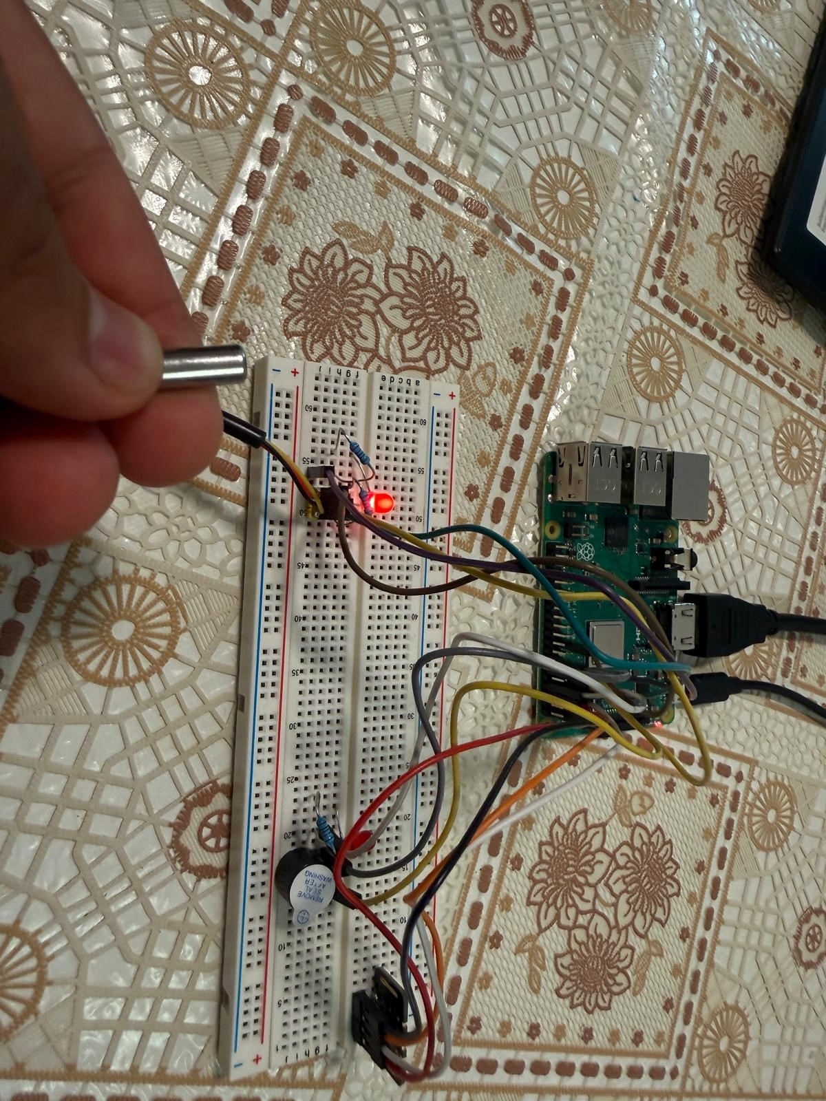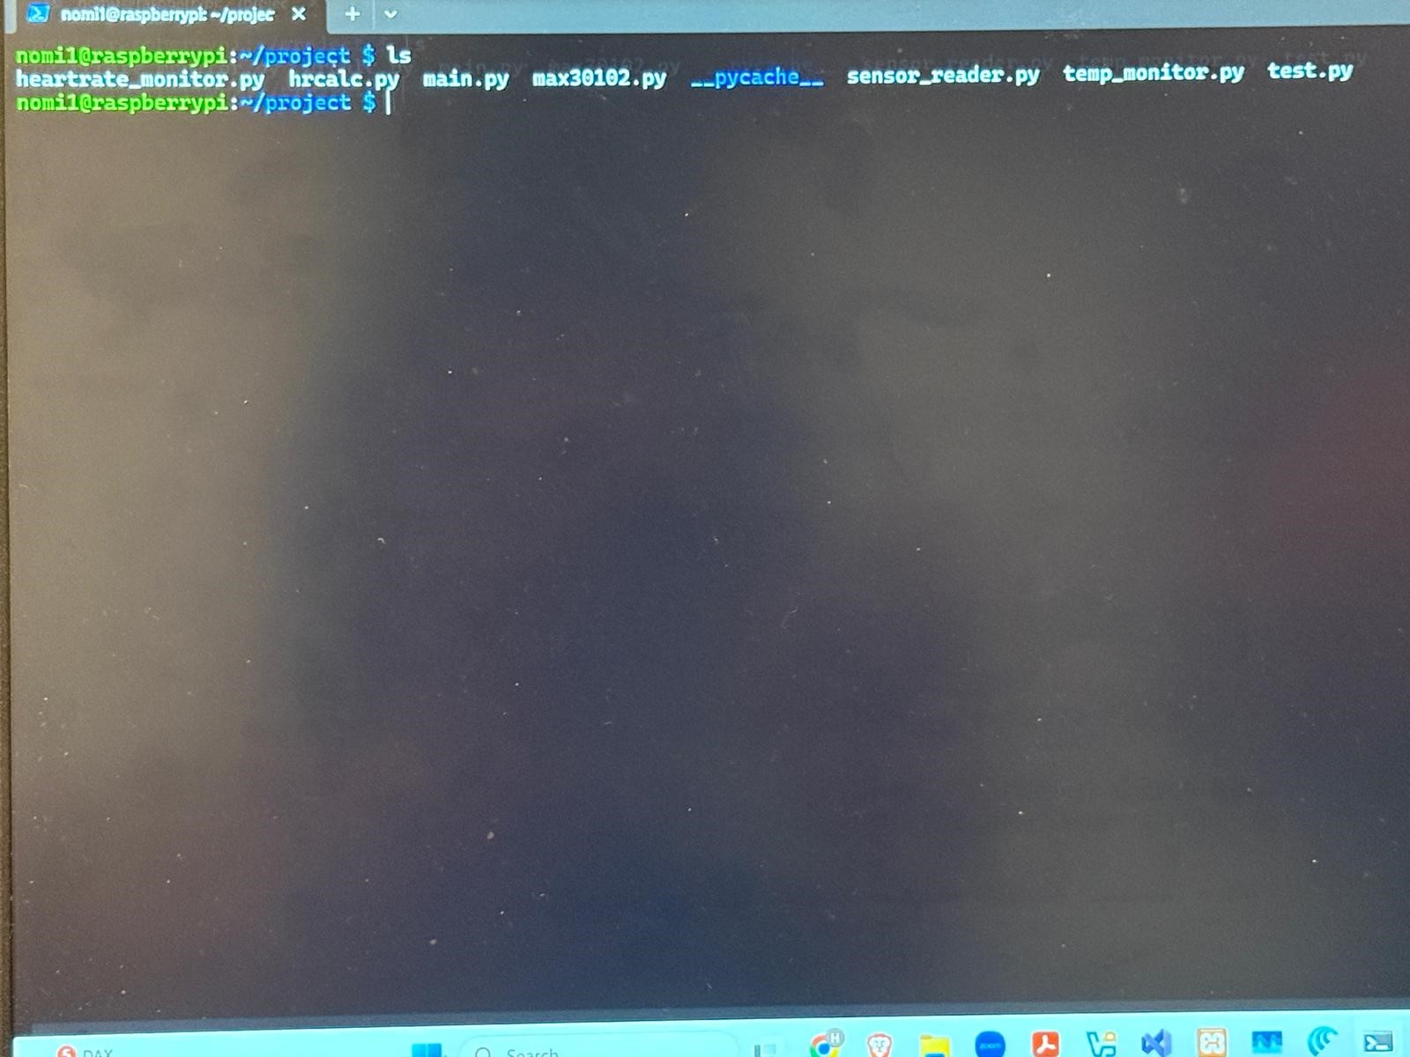
Figure 5: Alarm output (threshold exceeded) Figure 6: Web dashboard (MedHealth Monitor)

